Chapter 1, Problem 8.

The current flowing past a point in a device is shown in Fig. 1.25. Calculate the total charge through the point.

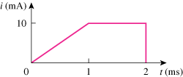

Figure 1.25
For Prob. 1.8.

